Question 1: - Write a program to calculate area of circle.

Public Class Form1

Dim rad As Double

Dim ar As Double

Private Sub PictureBox1_Click(sender As System.Object, e As System.EventArgs)

End Sub

Private Sub TextBox1_TextChanged(sender As System.Object, e As System.EventArgs) Handles TextBox.TextChanged

End Sub

Private Sub Button1_Click(sender As System.Object, e As System.EventArgs) Handles Area.Click

rad = TextBox.Text

ar = 3.14 * 3.14 * rad

MessageBox.Show(ar, "Area of Circle")

End Sub

End Class

OUTPUT

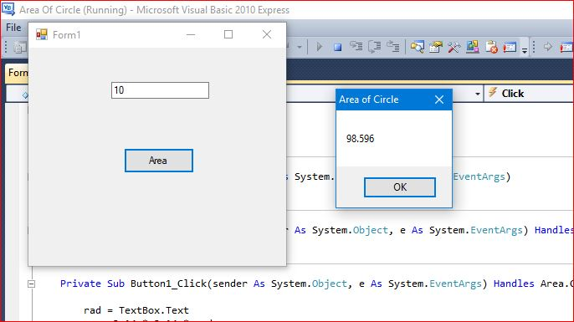

Question 2: - Write a program to add two numbers.

Public Class Addition

Dim num1 As Integer

Dim num2 As Integer

Dim addition As Integer

Private Sub Add_Click(sender As System.Object, e As System.EventArgs) Handles Add.Click

num1 = TextBox1.Text

num2 = TextBox2.Text

addition = num1 + num2

MessageBox.Show(addition, "Addition")

End Sub

End Class

OUTPUT

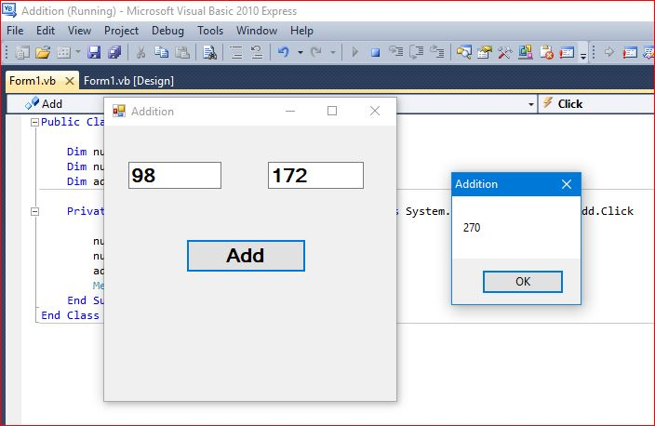

Question 3: - Question to find greatest of three numbers.

Public Class Form1

Dim a As Integer

Dim b As Integer

Dim c As Integer

Dim largest As Integer

Private Sub Find_Click(sender As System.Object, e As System.EventArgs) Handles Find.Click

a = TextBox1.Text

b = TextBox2.Text

c = TextBox3.Text

If a > b And a > c Then

largest = c

ElseIf b > a And b > c Then

largest = b

ElseIf c > a And c > b Then

largest = c

End If

MessageBox.Show(largest, "Greatest of Three Numbers")

End Sub

End Class

OUTPUT

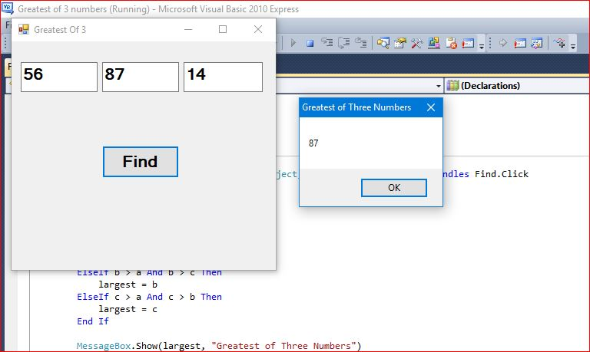

Question 4: - Write a program to swap two numbers without using third variable.

Public Class Form1

Dim num1 As Integer

Dim num2 As Integer

Private Sub Swap_Click(sender As System.Object, e As System.EventArgs) Handles Swap.Click

num1 = TextBox1.Text

num2 = TextBox2.Text

TextBox3.Text = num1

TextBox4.Text = num2

num1 = num1 + num2

num2 = num1 - num2

num1 = num1 - num2

TextBox5.Text = num1

TextBox6.Text = num2

MessageBox.Show("Value Swapped", " Swap value")

End Sub

End Class

OUTPUT

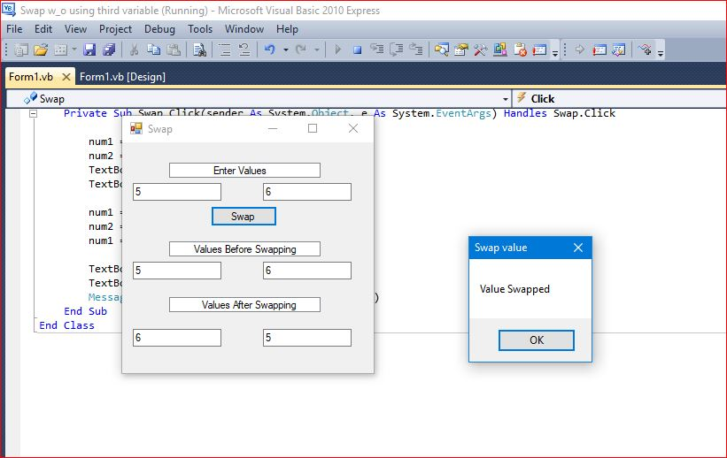

Question 5: - Write a Program that prints the grade of a student depending upon the marks obtained.

|  |  |
| --- | --- |
| MARKS 90 - 100 | GRADE A |
| MARKS 80-89 | GRADE B |
| MARKS 70-79 | GRADE C |
| MARKS 60-69 | GRADE D |
| MARKS LESS THAN 60 | GRADE E |

Public Class Grades

Dim marks As Integer

Private Sub TextBox1_TextChanged(sender As System.Object, e As System.EventArgs) Handles TextBox1.TextChanged

End Sub

Private Sub Grade_Click(sender As System.Object, e As System.EventArgs) Handles Grade.Click

marks = TextBox1.Text

If (marks >= 90) And (marks <= 100) Then

MessageBox.Show("Grade A", "Your Grade")

ElseIf (marks >= 80) And (marks <= 89) Then

MessageBox.Show("Grade B", "Your Grade")

ElseIf (marks >= 70) And (marks <= 79) Then

MessageBox.Show("Grade C", "Your Grade")

ElseIf (marks >= 60) And (marks <= 69) Then

MessageBox.Show("Grade D", "Your Grade")

Else

MessageBox.Show("Grade E", "Your Grade")

End If

End Sub

End Class

OUTPUT

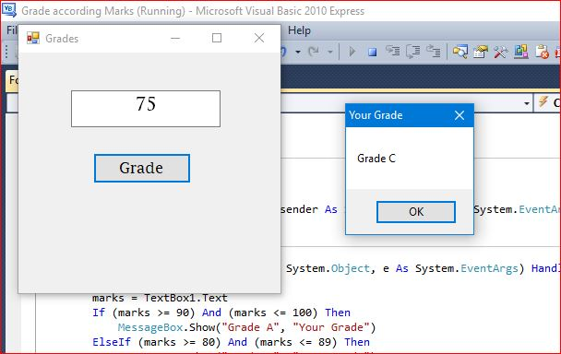

Question 6: - Write a menu Driven Program that accepts two numbers from the user. The program should implement all the mathematical operations like ADDITION, SUBTRACTION, DIVISION, MULTIPLICATION and POWER. Depending on User’s Choice.

Public Class Form1

Dim num1 As Integer

Dim num2 As Integer

Dim input As Integer

Dim sum As Integer

Dim diff As Integer

Dim product As Integer

Dim ratio As Integer

Dim power As Integer

Private Sub Calculate_Click(sender As System.Object, e As System.EventArgs) Handles Calculate.Click

num1 = TextBox1.Text

num2 = TextBox2.Text

input = TextBox3.Text

Select Case input

Case 1

sum = num1 + num2

TextBox4.Text = sum

MessageBox.Show("Numbers Added", "Addition")

Case 2

diff = num1 - num2

TextBox4.Text = diff

MessageBox.Show("Numbers Subtracted", "Subtraction")

Case 3

product = num1 * num2

TextBox4.Text = product

MessageBox.Show("Numbers Multiplied","Multiplication")

Case 4

ratio = num1 / num2

TextBox4.Text = ratio

MessageBox.Show("Numbers Divided", "Division")

Case 5

power = num1 ^ num2

TextBox4.Text = power

MessageBox.Show("Number Raised", "Power")

End Select

End Sub

End Class

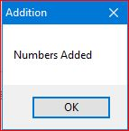 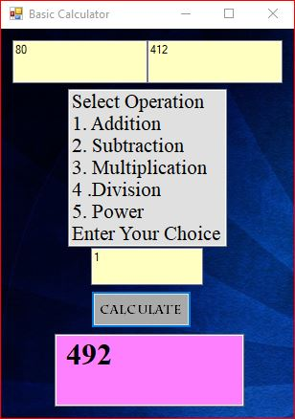

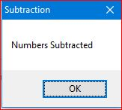 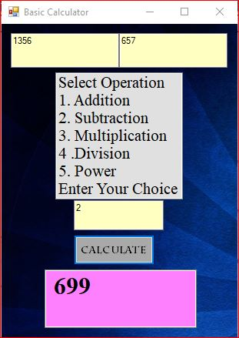

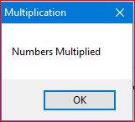 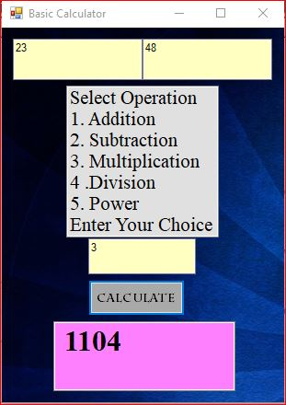

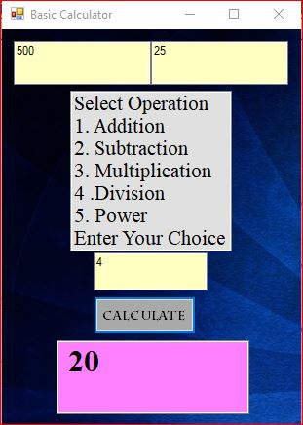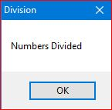

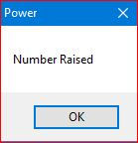 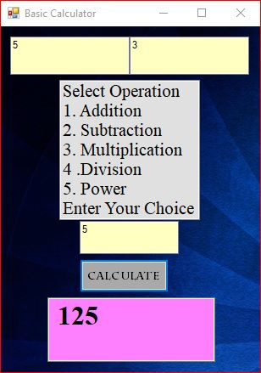

Question 7: - Write a program that prints factorial of a number.

Public Class Form1

Dim fact As Integer = 1

Dim n As Integer

Private Sub Factorial_Click(sender As System.Object, e As System.EventArgs) Handles Factorial.Click

n = TextBox1.Text

For i = n To 1 Step -1

fact = fact * i

Next

MessageBox.Show("Factorial of " & n & " is " & fact, "Factorial")

End Sub

End Class

OUTPUT

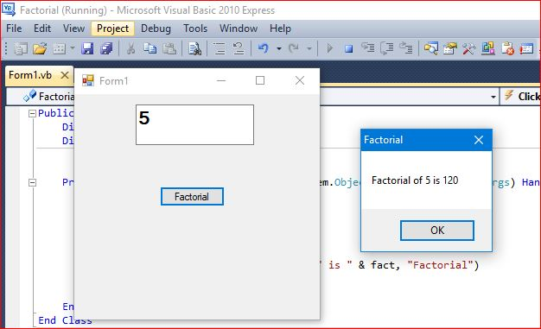

Question 8: - Write a Program to Print Fibonacci Series.

Public Class Fibonacci

Function Fibonacci (ByVal n As Integer) As Integer

Dim a As Integer = 0

Dim b As Integer = 1

Dim fib As Integer

Do

Label1.Text += a.ToString & ControlChars.NewLine

fib = a + b

a = b

b = fib

Loop While a <= 55

Return fib

End Function

Private Sub Print_Click(sender As System.Object, e As System.EventArgs) Handles Print.Click

Dim n As Integer

MessageBox.Show(Fibonacci(n))

End Sub

End Class

Output

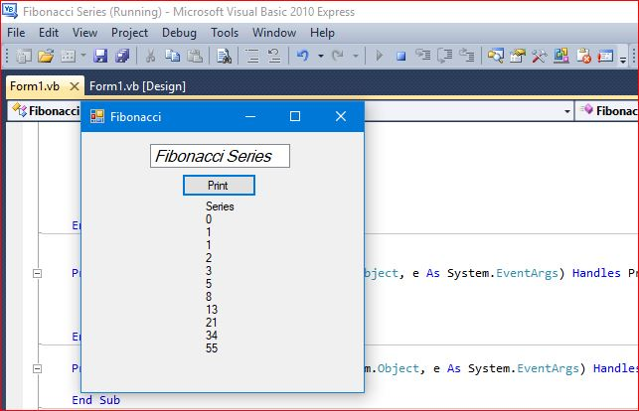

Question 9: - Write a Program to Print Prime Numbers Between 2 to 100.

Public Class Prime

Private Sub Print_Click(sender As System.Object, e As System.EventArgs) Handles Print.Click

Dim p, n, i As Integer

p = 1

For n = 1 To 100

For i = 2 To n - 1

If n Mod i = 0 Then

p = 0

Exit For

Else

p = 1

End If

Next

If p = 1 Then

ListBox1.Items.Add(n)

End If

Next

End Sub

OUTPUT

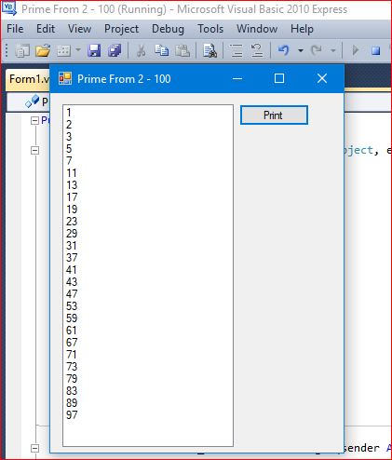

Question 10: - Write a Program to Reverse a Number.

Public Class Reverse

Dim NUM As Integer

Dim REV As Integer, REMINDER As Integer

Private Sub Reverse_Load(sender As System.Object, e As System.EventArgs) Handles MyBase.Load

End Sub

Private Sub Button1_Click(sender As System.Object, e As System.EventArgs) Handles Button1.Click

REV = 0

NUM = TextBox1.Text

TextBox2.Text = NUM

Do While NUM <> 0

REMINDER = NUM Mod 10

REV = REV * 10 + REMINDER

NUM = NUM \ 10

Loop

TextBox3.Text = REV

End Sub

End Class

OUTPUT

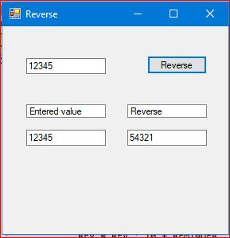

Question 11: - Write a Program to Check whether a number is prime or not.

Public Class Prime

Private Sub Prime_Click(sender As System.Object, e As System.EventArgs) Handles Prime.Click

Dim check As Integer

check = 1

Dim num As Integer

num = TextBox1.Text

For i As Integer = 2 To (num - 1)

If num Mod i = 0 Then

check = 0

Exit For

End If

Next

If check = 0 Then

MessageBox.Show("Not prime")

Else

MessageBox.Show("prime")

End If

End Sub

End Class

OUTPUT

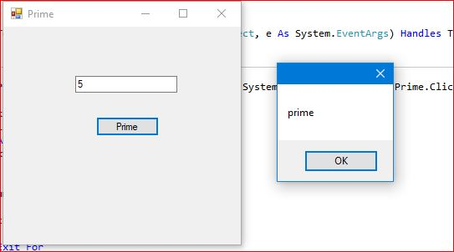

Question 12: - Write a Program for Structured Exception.

Public Class Division

Dim dividend As Integer

Dim divisor As Integer

Private Sub TextBox3_TextChanged(sender As System.Object, e As System.EventArgs) Handles TextBox3.TextChanged

End Sub

Private Sub Button1_Click(sender As System.Object, e As System.EventArgs) Handles Button1.Click

dividend = TextBox1.Text

divisor = TextBox2.Text

Dim result As Double

Try

result = dividend \ divisor

Catch ex As Exception

MessageBox.Show("exception caught:-" & ex.Message, "example of exception")

Finally

MessageBox.Show("Result:-" & result, "example of exception handling")

End Try

TextBox3.Text = result

End Sub

End Class

OUTPUT

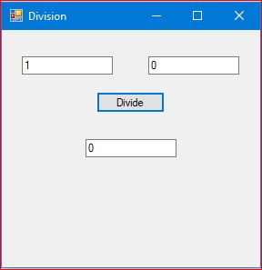

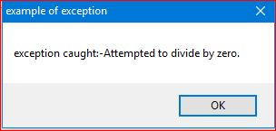

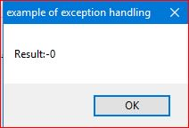

Question 13: - Write a Program for Unstructured Exception.

Public Class Form1

Dim divisor As Integer

Dim dividend As Integer

Dim result As Integer

Private Sub Form1_Load(sender As System.Object, e As System.EventArgs) Handles MyBase.Load

End Sub

Private Sub Divide_Click(sender As System.Object, e As System.EventArgs) Handles Divide.Click

Dim msg As String

divisor = TextBox2.Text

dividend = TextBox1.Text

On Error Resume Next

TextBox3.Text = dividend \ divisor

Err.Clear()

Err.Raise(33333)

Err.Description = "you have entered divisor a value zero"

MessageBox.Show("error number:" & Err.Number)

MessageBox.Show("error number:" & Err.Description)

msg = "press F1 or HELP to see" & Err.HelpFile & " topic for " & "the following help content:" & Err.HelpContext

MessageBox.Show(msg)

End Sub

End Class

OUTPUT

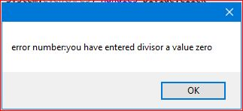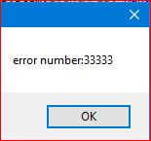

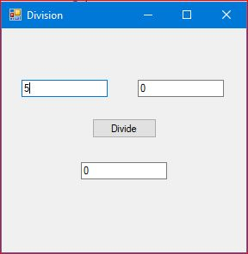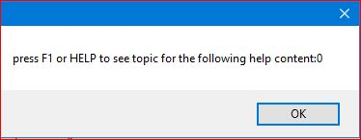

Question 14: - Write a Program to Show working of Different Procedures.

EVENT PROCEDURE:

Public Class Form1

Private Sub Form1_Load(sender As Object, e As EventArgs) Handles MyBase.Load

End Sub

Private Sub Button1_Click(sender As Object, e As EventArgs) Handles Button1.Click

Label1.Text = "Your Name"

Label1.ForeColor = Color.Red

Button1.Text = "Done"

Button1.ForeColor = Color.DarkMagenta

End Sub

End Class

OUTPUT

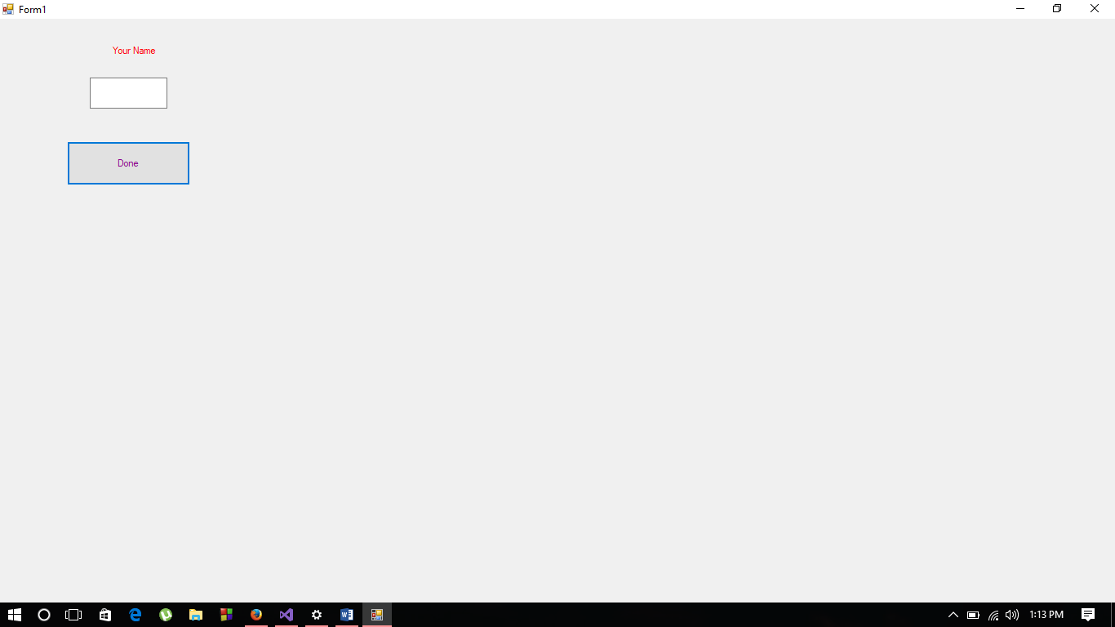

PROPERTY PROCEDURE:

Public Class Form1

Dim firstname, lastname As String

Property fullname() As String

Get

If lastname = "" Then

Return firstname

Else

Return firstname & " " & lastname

End If

End Get

Set(ByVal Value As String)

Dim check As Integer = Value.IndexOf(" ")

If check < 0 Then

firstname = Value

lastname = ""

Else

firstname = Value.Substring(0, check)

lastname = Value.Substring(check + 1)

End If

End Set

End Property

Private Sub Form1_Load(sender As Object, e As EventArgs) Handles MyBase.Load

End Sub

Private Sub Button1_Click(sender As Object, e As EventArgs) Handles Button1.Click

fullname = TextBox1.Text

MessageBox.Show(fullname)

End Sub

End Class

OUTPUT

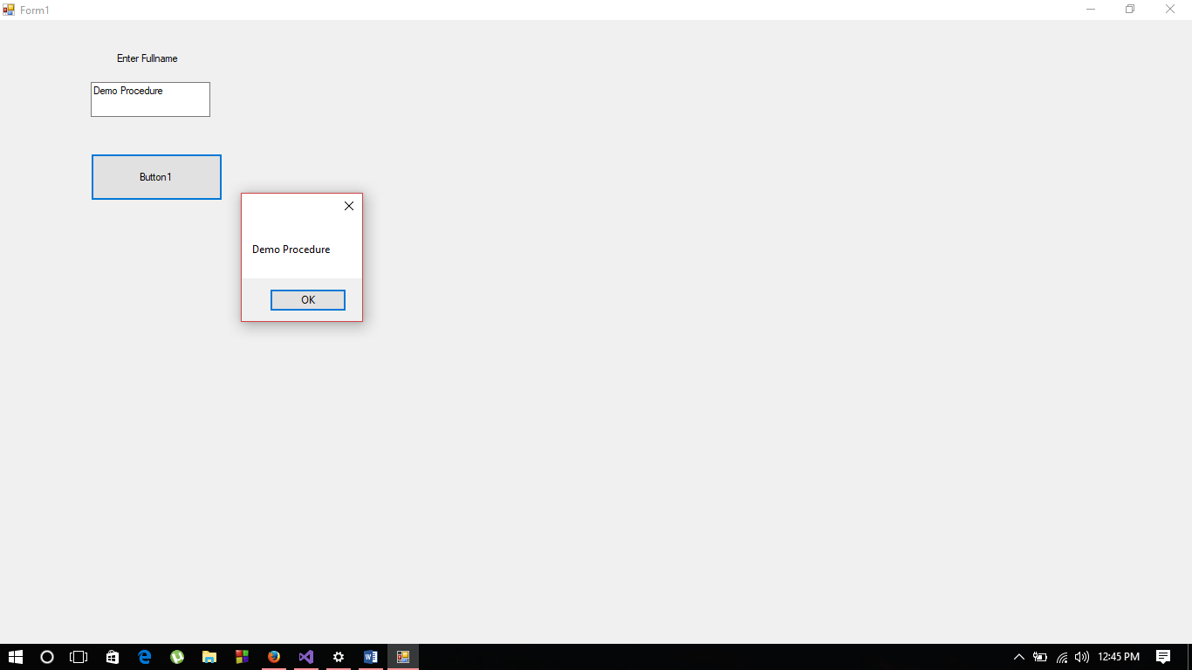

OPERATOR PROCEDURE:

Public Class Form1

Class complex

Dim real, imaginary As Integer

Public Sub Input(ByVal a As Integer, ByVal b As Integer)

real = a

imaginary = b

End Sub

Public Sub Show()

MessageBox.Show(real & "+i" & imaginary)

End Sub

Public Shared Operator +(ByVal v1 As complex, ByVal v2 As complex)

Dim temp As New complex

temp.real = v1.real + v2.real

temp.imaginary = v1.imaginary + v2.imaginary

Return temp

End Operator

End Class

Private Sub Form1_Load(sender As Object, e As EventArgs) Handles MyBase.Load

End Sub

Private Sub Button1_Click(sender As Object, e As EventArgs) Handles Button1.Click

Dim obj1, obj2, obj3 As New complex

obj1.Input(TextBox1.Text, TextBox2.Text)

obj2.Input(TextBox3.Text, TextBox4.Text)

obj3 = obj1 + obj2

obj3.Show()

End Sub

Private Sub Label1_Click(sender As Object, e As EventArgs) Handles Label1.Click

End Sub

End Class

OUTPUT

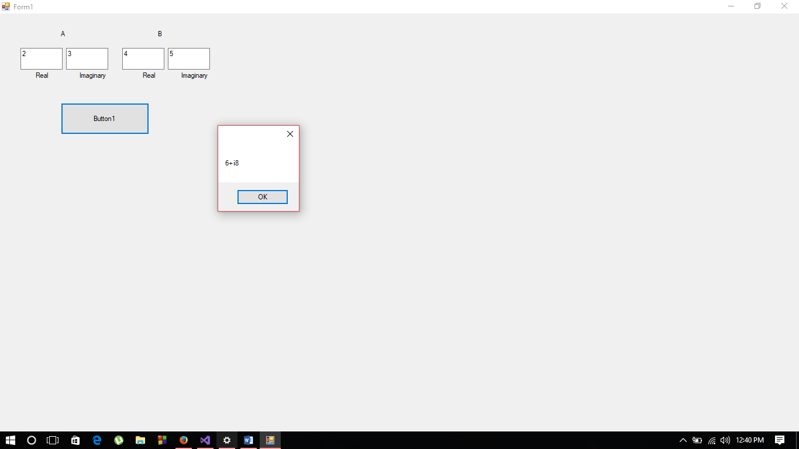

FUNCTION PROCEDURE:

Public Class Form1

Dim val1, val2, val3 As Integer

Private Sub Form1_Load(sender As Object, e As EventArgs) Handles MyBase.Load

End Sub

Public Function Sum(ByRef x As Integer, ByVal y As Integer)

Dim c As Integer = x + y

Return c

End Function

Private Sub Button1_Click(sender As Object, e As EventArgs) Handles Button1.Click

val1 = TextBox1.Text

val2 = TextBox2.Text

val3 = Sum(val1, val2)

MessageBox.Show("Sum = " & val3)

End Sub

End Class

OUTPUT

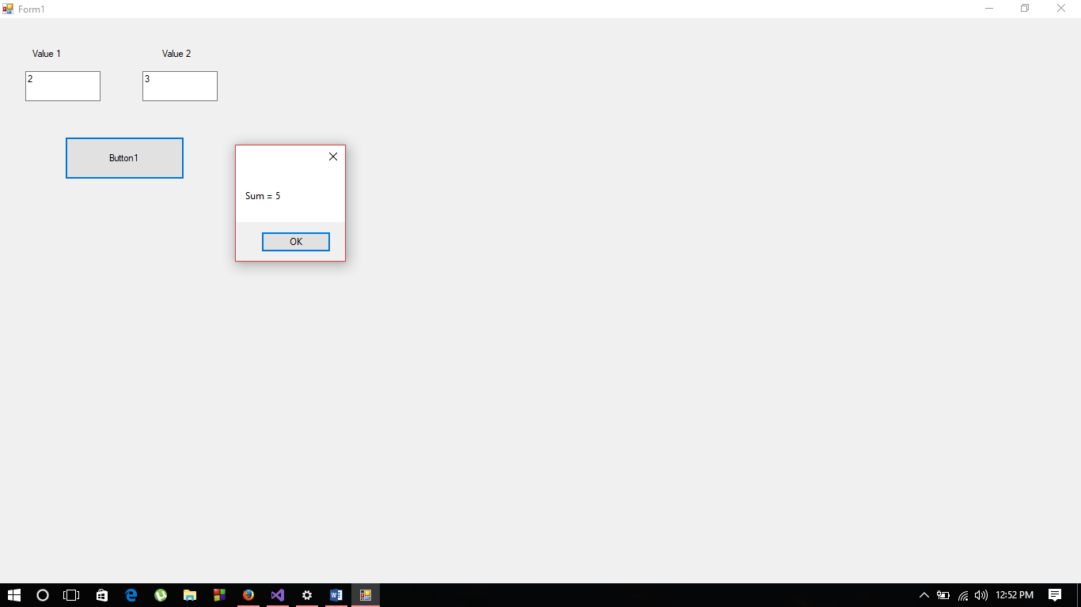

SUB PROCEDURE:

Public Class Form1

Dim fullname As String

Private Sub Form1_Load(sender As Object, e As EventArgs) Handles MyBase.Load

End Sub

Public Sub Welcome(ByVal name As String)

MessageBox.Show("Welcome " & name)

End Sub

Private Sub Button1_Click(sender As Object, e As EventArgs) Handles Button1.Click

fullName = TextBox1.Text

Welcome(fullname)

End Sub

End Class

OUTPUT

